Scalability Solutions for Blockchain

Pavithra.S, 2022MT93172

ABSTRACT Blockchain technology has the potential to transform several industries by enabling secure and transparent transactions in a decentralized manner. However, the issue of scalability has hindered its mainstream adoption. To address this challenge, various scalability solutions have been developed. This report aims to provide an overview of the various scalability solutions available for blockchain technology. The scalability solutions are categorized into four distinct categories: First Layer Scalability Solutions, Second Layer Scalability Solutions, Scalable Consensus Algorithms, and Scalable Distributed Ledgers. Each classification presents distinct approaches to addressing the scalability issues encountered by blockchain technology. The report compares the scalability solutions and evaluates the effectiveness of each solution in addressing the scalability issue. It also discusses the potential challenges and drawbacks associated with each solution. The report concludes by summarizing the main findings and discussing the potential future of blockchain scalability solutions.

INDEX TERMS Blockchain, Byzantine Fault Tolerance, Consensus Algorithm, Decentralization, Delegated Proof of Stake, Efficiency, Hard Forks, Interoperability, Layer 1 Solutions, Layer 2 Solutions, Lightning Network, Network Performance, Off-chain Solutions, On-chain Solutions, Plasma, Proof of Authority, Scalability, Segregated Witness, Security, Sharding, Sidechains, Smart Contracts, State Channels

1. INTRODUCTION

In the recent years, blockchain technology has been gaining a lot of attention due to its potential to disrupt various industries and enable new applications that were previously not possible. Although blockchain technology has shown promising potential in various fields, its scalability remains a significant challenge. This scalability issue can limit the adoption and growth of blockchain technology, especially for applications that require high throughput and low latency.

Scalability in the context of blockchain technology pertains to the network's capacity to accommodate a significant volume of transactions per second (TPS) and to expand its capacity as the number of users and transactions increases.

Scalability is a critical issue for blockchain technology because many blockchain networks, such as Bitcoin and Ethereum, are designed to be decentralized and secure by relying on a network of nodes that collectively validate and confirm transactions. As more users and transactions are added to the network, the computational and storage requirements for each node can increase, which can lead to slower transaction processing times, higher fees, and reduced network performance.

1. BLOCKCHAIN SCALABILITY SOLUTIONS

Blockchain scalability is a major challenge that needs to be addressed for blockchain to achieve mainstream adoption. Developers are working on different types of solutions to overcome this issue, which can be broadly classified into four distinct categories. Each category includes different strategies to tackle and handle the scalability challenges in the blockchain.

1. First layer scalability solutions.
2. Second layer scalability solutions.
3. Scalable consensus mechanisms.
4. Scalable distributed mechanisms.

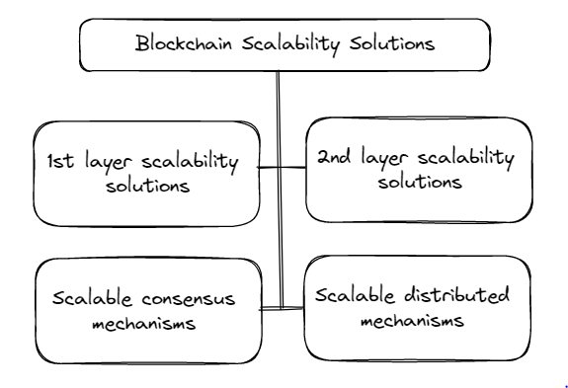

1. FIRST-LAYER SCALABILITY SOLUTIONS

First-layer scalability solutions, also known as on-chain solutions, aim to improve blockchain scalability by optimizing the underlying blockchain protocol itself. These solutions involve making changes to the consensus mechanism, block size, block time, or other fundamental aspects of the blockchain.

The techniques that are included in the first layer scalability solutions are as follows,

* Sharding
* Segregated Witness
* Hard Forks

Overall, first-layer scalability solutions can provide significant improvements in blockchain scalability, but they require changes to the underlying blockchain protocol, which can be difficult to implement and may require community consensus.

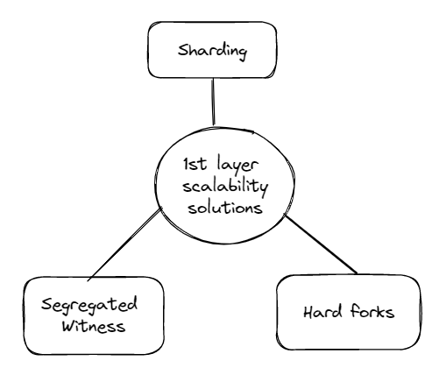

1. Sharding

Sharding works by breaking up the blockchain's data and processing load into smaller parts, or shards, that can be processed in parallel by different nodes. Each shard has its own set of nodes that are responsible for validating and confirming transactions within the shard. By distributing the workload across multiple shards, sharding can significantly increase the TPS of a blockchain network and reduce the burden on individual nodes. Second-layer scalability solutions are off-chain solutions that provide a way to process transactions without executing them on the main blockchain.

**Benefits of sharding for blockchain scalability:**

Sharding breaks up the blockchain's data and processing load into smaller parts, or shards, that can be processed in parallel by different nodes. This increases the TPS of a blockchain network to a much higher level than a single node or a small group of nodes can handle.

Sharding can increase the capacity and scalability of a blockchain network without sacrificing decentralization and security. It preserves the decentralized and secure nature of blockchain technology by distributing the workload across multiple shards and **nodes**.

**Challenges of sharding for blockchain scalability:**

Ensuring that the shards remain secure and do not compromise the integrity of the network. This requires various techniques, such as cross-shard communication and state synchronization, to enable the different shards to communicate and synchronize their data in a secure and efficient manner.

Ensuring that the shards are evenly distributed and that the processing load is balanced across different nodes and shards. This requires careful planning and design of the sharding architecture and algorithms, as well as monitoring and adjustment of the network to ensure optimal performance and scalability.

**Successful implementations of sharding:**

Zilliqa is a high-performance blockchain platform that uses sharding to achieve a throughput of up to 2,828 TPS, compared to Ethereum's current TPS of around 15.

Ethereum 2.0 is a major upgrade to the Ethereum network that introduces sharding and other scalability solutions to improve the performance and capacity of the network.

In conclusion, sharding is a promising scalability solution for blockchain technology that can increase the TPS and capacity of a blockchain network while preserving its decentralized and secure nature. However, implementing sharding requires careful planning, design, and monitoring to ensure optimal performance and security. Several blockchain projects have already implemented sharding, and it is expected that more will follow as the demand for scalable blockchain networks continues to grow.

1. Segregated Witness

Segregated Witness (SegWit) is a scalability solution for blockchain that separates the transaction signature data from the transaction data. This helps reduce the size of transactions, allowing more of them to fit into a single block and improving the overall throughput of the blockchain network.

**Benefits:**

Increased Transaction Capacity: SegWit increases the transaction capacity of the Bitcoin network by increasing the block size limit and enabling more transactions to be processed per block.

Lower Transaction Fees: SegWit reduces the size of transactions, which results in lower transaction fees for users.

Improved Transaction Malleability: SegWit fixes a long-standing issue with transaction malleability, which makes Bitcoin transactions more secure and less prone to errors.

Enables New Features: SegWit enables the implementation of new features such as the Lightning Network, which allows for instant and low-cost Bitcoin transactions.

**Challenges**:

Adoption: One of the biggest challenges facing SegWit is adoption. While many Bitcoin users and exchanges have upgraded to support SegWit, not all of them have. This can lead to slower transaction times and higher fees for users who are not using SegWit.

Compatibility: SegWit is not compatible with all Bitcoin wallets and services, which can make it difficult for some users to take advantage of its benefits.

Complexity: SegWit is a complex change to the Bitcoin protocol, and implementing it requires significant technical expertise. This can make it difficult for smaller Bitcoin companies and developers to adopt and implement.

Reduced Transparency: SegWit removes the signature data from the main part of the transaction, which can make it more difficult for users to audit the blockchain and track the flow of funds. However, this issue is mitigated by additional tools and software that enable users to verify the integrity of the transactions.

In conclusion, Segregated Witness is a promising scalability solution for blockchain technology that can increase the throughput and capacity of a blockchain network without requiring a hard fork or major protocol upgrade. However, widespread adoption and compatibility with existing blockchain applications are important factors for its success.

1. Hard Forks

Hard forks are a common approach to implement major changes to a blockchain network, including improvements to scalability. A hard fork occurs when a change in the protocol of a blockchain network is not backward compatible, resulting in the creation of a new chain that is different from the old one. This means that the new chain cannot be validated by nodes running the old protocol, and vice versa.

**Benefits:**

Hard forks can introduce new features or improvements to a blockchain network that are not backward compatible with older versions of the network. This allows for innovation and progress in the technology, improving its functionality and utility.

Hard forks can also resolve disagreements and conflicts within the community or development team of a blockchain network. If there are major disagreements about the direction of the network or the implementation of new features, a hard fork can create a new separate network with a different protocol and governance structure.

**Challenges:**

One of the main challenges of a hard fork is that it can lead to a split in the community and user base of a blockchain network. This can result in a loss of trust and value in the network, as well as confusion and uncertainty about which version of the network is the legitimate one.

Hard forks can also create a potential security risk, as the new version of the network may not have the same level of security as the previous version. The network will thus become more vulnerable to attacks and exploits until the proper security is established and tested in all aspects.

Finally, a hard fork can also create technical challenges, such as compatibility issues with wallets and other software that are designed for the previous version of the network. This can make it more difficult for users and developers to migrate to the new version and may result in a delay or slow adoption of the new network.

In conclusion, hard forks can be a powerful tool for introducing new features and resolving disagreements in a blockchain network, but they also come with significant challenges and risks. Proper planning, communication, and testing are essential to minimize the negative effects of a hard fork and ensure a smooth transition to the new version of the network.

1. SECOND-LAYER SCALABILITY SOLUTIONS

Second-layer scalability solutions are off-chain solutions that provide a way to process transactions without executing them on the main blockchain. The second layer solutions are designed to tackle the problem of scalability by transferring some of the processing from the main blockchain to a secondary layer. By implementing this approach, the quantity of information that requires storage on the primary blockchain is minimized, ultimately enhancing scalability. The main advantage of this approach is that it increases the throughput of the network by allowing a large number of transactions to be processed in a short period of time.

The techniques that are included in the first layer scalability solutions are as follows,

* State Channels
* Sidechains
* Plasma
* Lightning Network

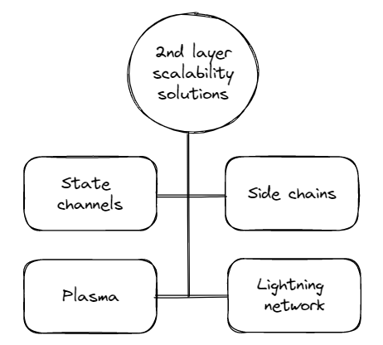

Overall, second-layer solutions offer a promising approach to addressing blockchain scalability challenges by enabling a significant increase in transaction throughput while minimizing the amount of data that needs to be stored on the main blockchain. However, implementing these solutions can be challenging and require significant technical expertise, as well as careful consideration of security and decentralization trade-offs.

A. State Channels

State channels are a type of off-chain scaling solution that allows for fast and cheap microtransactions. State channels work by creating a private channel between two parties that enables them to conduct multiple transactions without having to write each transaction to the blockchain. Instead, the final state of the channel is recorded on the blockchain once the channel is closed.

**Benefits:**

State channels can process a high volume of transactions with minimal fees, making them a highly efficient solution for small and frequent transactions.

Transactions conducted through state channels are private and secure as they do not need to be broadcasted publicly on the blockchain.

State channels can provide instant transaction confirmation, which makes them well-suited for use cases that require fast and frequent transactions.

**Challenges:**

State channels require a high degree of trust between the parties involved in the transaction, as any attempt to cheat or alter the channel's state can result in the loss of funds.

The initial setup of a state channel requires an on-chain transaction, which can be costly and time-consuming.

State channels may not be suitable for use cases that involve complex smart contracts or transactions that require inputs from multiple parties.

State channels are widely used in various blockchain applications, such as gaming, betting, and micropayments. For example, the Lightning Network, a second-layer solution built on top of the Bitcoin blockchain, uses state channels to enable instant and low-cost Bitcoin transactions.

Overall, state channels offer a highly scalable and efficient solution for small and frequent transactions. However, the high degree of trust required and limitations in use cases may hinder their adoption in certain applications. Nonetheless, state channels remain an important component of the blockchain ecosystem and are expected to play a significant role in the future development of blockchain technology.

B. Side Chains

Sidechains are a type of second-layer scaling solution that enable the transfer of digital assets between different blockchain networks. Sidechains are essentially independent blockchains that are interoperable with the main blockchain network, which enables them to leverage the security and decentralization of the main chain while also providing additional functionality and scalability.

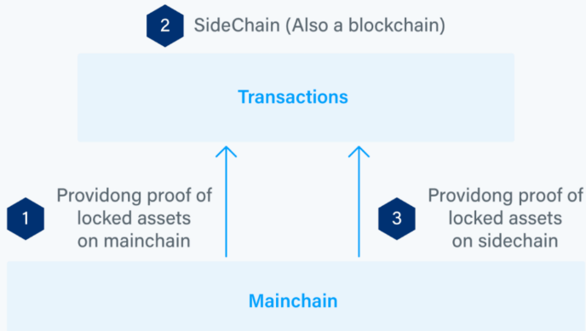

**Benefits:**

Sidechains enable the creation of new applications and use cases that may not be possible on the main blockchain network due to its limitations in terms of scalability and functionality.

Transactions on sidechains can be processed quickly and efficiently, as they do not have to be processed by the main blockchain network. This can result in faster confirmation times and lower transaction fees.

Sidechains can be customized to meet the specific needs of different use cases and applications, which can result in increased flexibility and innovation.

**Challenges:**

Sidechains introduce a certain level of centralization, as they rely on a limited number of validators to secure the network. This can potentially compromise the decentralization and security of the blockchain network.

Transferring assets between the main blockchain network and the sidechain requires a trustless bridge, which can be difficult to implement and can introduce additional security risks.

The success of a sidechain depends on its ability to attract users and developers, which can be challenging in a competitive blockchain ecosystem.

Overall, sidechains are a promising solution for improving the scalability and functionality of blockchain networks. However, they also introduce new challenges and risks that must be carefully considered and addressed. Several blockchain projects, such as Liquid and RSK, have successfully implemented sidechains to improve the performance and capabilities of their networks.

C. Plasma

Plasma is a layer-two scaling solution that aims to increase the scalability and speed of blockchain networks by creating hierarchical tree structures of blockchains, also known as plasma chains. These plasma chains are built on top of the main blockchain, and they process transactions off-chain before eventually committing them to the main chain.

**Benefits:**

Plasma can significantly increase the transaction processing speed of a blockchain network by processing transactions off-chain before committing them to the main chain.

Plasma can increase the capacity of a blockchain network by allowing for the creation of multiple plasma chains that can process transactions in parallel.

Plasma can enable the creation of specialized blockchains that are designed for specific use cases, such as gaming or decentralized exchanges, without compromising the security and decentralization of the main chain.

**Challenges:**

One of the main challenges of plasma is ensuring the security and integrity of the plasma chains, as they are not directly tied to the main chain and may be vulnerable to attacks. Various techniques such as fraud proofs and challenge responses are used to mitigate this risk.

Plasma requires a significant amount of computational power to maintain the integrity of the plasma chains and ensure that they are in sync with the main chain.

The development and implementation of plasma require a high degree of technical expertise and resources.

Despite these challenges, plasma is an important scaling solution for blockchain networks that has the potential to significantly increase the speed and capacity of blockchain networks while preserving their security and decentralization. Several blockchain projects, such as Omisego and Matic Network, have implemented plasma or variations of it to improve the performance of their networks.

D. Lightning Network

The Lightning Network is a layer-two scaling solution for Bitcoin and other cryptocurrencies that aims to improve transaction speeds and reduce fees. It operates by creating a network of payment channels that allow users to conduct off-chain transactions with each other. These transactions are only recorded on the blockchain when the channel is closed, resulting in faster and cheaper transactions.

**Benefits:**

Lightning Network transactions are fast and low-cost, making it an ideal solution for small, frequent transactions that would otherwise be too expensive to conduct on-chain.

It enables micropayments, which opens up new use cases for cryptocurrencies, such as pay-per-view content and micro-tipping.

It is highly scalable, as the number of transactions that can be conducted through the Lightning Network is not limited by the capacity of the underlying blockchain.

**Challenges:**

The Lightning Network is still in the early stages of development, and there are concerns around its security and stability.

Setting up payment channels can be complex and requires a high degree of technical knowledge, which can limit its accessibility to non-technical users.

As the Lightning Network grows, it could potentially lead to centralization, as larger nodes with more liquidity would have more power in the network.

In conclusion, the Lightning Network is a promising layer-two scaling solution that can significantly improve the speed and efficiency of cryptocurrency transactions. However, it is still a nascent technology, and there are challenges that need to be addressed to ensure its long-term viability. With ongoing development and improvements, the Lightning Network has the potential to play a significant role in the adoption and mainstream use of cryptocurrencies.

1. SCALABLE CONSENSUS MECHANISMS

Scalable consensus algorithms are a class of algorithms designed to address the scalability challenges of traditional blockchain consensus algorithms The standard consensus algorithms, including Proof-of-Work (PoW) and Proof-of-Stake (PoS), require the involvement of all nodes in the network for consensus formation. This approach can become a bottleneck as the network grows in size, leading to slower transaction processing times and higher fees.

Scalable consensus algorithms aim to address this bottleneck by allowing for more efficient consensus mechanisms that can handle a larger number of nodes while still maintaining the security and integrity of the network.

Some of the scalable consensus mechanisms include,

* Delegated Proof-of-Stake
* Proof-of-Authority
* Byzantine Fault Tolerance

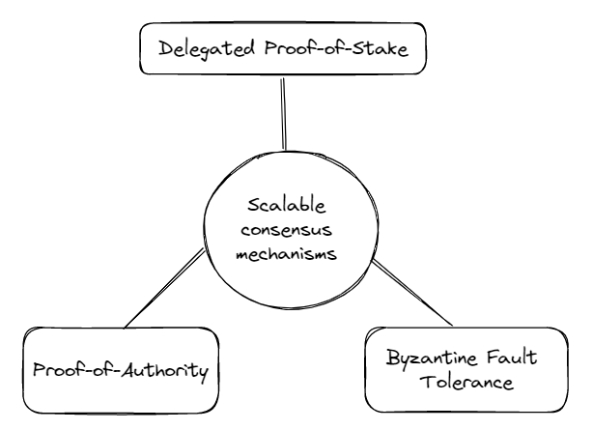

Overall, scalable consensus algorithms represent an important area of research in blockchain technology, as they offer a promising solution to the scalability challenges facing traditional blockchain consensus algorithms.

A. Delegated Proof of stake

Delegated Proof of Stake (DPoS) is a consensus algorithm used by many blockchain networks, including EOS and BitShares. DPoS aims to increase the scalability of blockchain networks by using a different approach to the traditional Proof of Work (PoW) and Proof of Stake (PoS) algorithms.

DPoS works by allowing stakeholders to vote for "delegates" who are responsible for creating blocks and validating transactions on the network. Delegates are chosen based on the number of votes they receive from stakeholders. The more votes a delegate receives, the higher their chance of being chosen to create the next block.

**Benefits:**

Scalability: DPoS has the potential to process thousands of transactions per second, making it highly scalable and efficient.

Energy efficiency: Unlike PoW, DPoS does not require a large amount of computational power or energy to validate transactions and create new blocks, making it a more energy-efficient alternative.

Decentralization: DPoS promotes decentralization by allowing stakeholders to vote for delegates who represent their interests on the network.

Reduced centralization: DPoS reduces the risk of centralization by limiting the power of individual delegates and requiring regular voting to ensure a fair and diverse set of delegates.

**Challenges:**

Stakeholder participation: DPoS requires active participation from stakeholders to vote for delegates, which may be a barrier to entry for some users.

Risk of collusion: DPoS introduces the risk of collusion between delegates, as they may work together to manipulate the network and undermine its security.

Unequal voting power: The voting power of stakeholders may be unequal, with larger stakeholders having more influence over the network.

Vulnerability to attacks: DPoS is vulnerable to attacks such as a 51% attack, where a group of delegates with a majority of voting power could take control of the network.

In conclusion, DPoS is a promising consensus algorithm that offers high scalability, energy efficiency, and decentralization. However, it also introduces some challenges, such as the risk of collusion and unequal voting power. Overall, DPoS may be a suitable consensus algorithm for blockchain networks that prioritize scalability and efficiency while maintaining a degree of decentralization.

B. Proof of Authority

Proof of Authority (PoA) is a consensus algorithm that is used in some blockchain networks to achieve scalability and fast transaction times. In PoA, a group of trusted validators are responsible for creating new blocks on the blockchain.

**Benefits:**

PoA allows for faster transaction times and higher scalability compared to other consensus algorithms, such as Proof of Work (PoW) and Proof of Stake (PoS).

Validators in a PoA system are known entities and are typically required to meet certain criteria, such as having a minimum stake in the network or holding a certain reputation within the community. This can result in a more centralized and predictable network.

PoA can be a more energy-efficient alternative to PoW, as it doesn't require expensive mining equipment and high energy consumption.

**Challenges:**

PoA can be vulnerable to a 51% attack if the majority of the validators collude to manipulate the network.

PoA relies heavily on the trustworthiness and integrity of the validators. If a validator is compromised, it can lead to the centralization of the network and potential security vulnerabilities.

The centralized nature of PoA can also lead to potential censorship and lack of transparency in decision-making.

In summary, Proof of Authority is a consensus algorithm that offers high scalability and fast transaction times, but its centralized nature and reliance on the trustworthiness of validators can pose potential security risks.

C. Byzantine Fault Tolerance

Byzantine Fault Tolerance (BFT) is a consensus algorithm used in distributed systems to achieve agreement on a single data value or decision, even in the presence of faulty nodes or malicious actors. BFT was first introduced in a 1982 paper by Leslie Lamport, Robert Shostak, and Marshall Pease, and has since been used in a variety of systems, including blockchain networks.

BFT algorithms rely on a group of validators, or nodes, to achieve consensus on the state of the network. These validators communicate with each other to exchange information about proposed transactions or blocks, and work together to agree on the final state of the network.

**Benefits of BFT:**

BFT algorithms can achieve fast and efficient consensus, even in the presence of faulty nodes or malicious actors.

BFT-based systems can be highly secure and resistant to attack, as malicious actors must overcome the agreement of the majority of validators to successfully manipulate the system.

BFT can be used in a variety of distributed systems, including blockchain networks, to achieve consensus on transaction order and validity.

**Challenges of BFT:**

BFT can be complex to implement, as it requires a group of validators to work together and agree on the state of the network.

BFT algorithms may require a high degree of network resources, such as computing power and bandwidth, to achieve consensus quickly and efficiently.

BFT may not be suitable for all use cases, particularly those that require high levels of decentralization or do not require consensus on every transaction.

**Variants of Byzantine Fault Tolerance:**

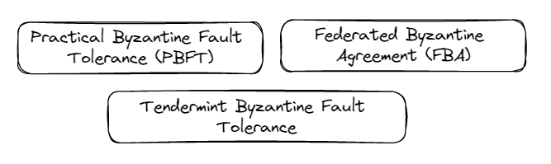

Practical Byzantine Fault Tolerance (PBFT): This is one of the earliest BFT algorithms and is designed for use in a permissioned network. PBFT ensures that all nodes in the network agree on the order of transactions and guarantees safety and liveness under a certain number of faults, such as node failures or malicious attacks. PBFT is widely used in permissioned blockchain platforms such as Hyperledger Fabric and Quorum.

Tendermint BFT: Tendermint is a BFT consensus engine that is optimized for scalability and high-performance blockchains. Tendermint uses a round-based voting protocol to reach consensus on the order of transactions and allows for fast block confirmations. Tendermint is used in several blockchain platforms, including Cosmos and Binance Chain.

Federated Byzantine Agreement (FBA): FBA is a family of BFT algorithms that use a quorum-based voting mechanism to reach consensus among nodes. In an FBA system, nodes are organized into quorums, and a certain number of quorums must agree on the order of transactions for consensus to be reached. Stellar, a payment network and cryptocurrency, uses an FBA consensus algorithm.

In conclusion, Byzantine Fault Tolerance (BFT) is a family of consensus algorithms that are designed to achieve agreement among distributed nodes in the presence of Byzantine faults. BFT algorithms are widely used in permissioned blockchain networks where participants are known and trusted. The different variants of BFT, such as PBFT, Tendermint, and HoneyBadger BFT, have different strengths and weaknesses, and are suited for different use cases depending on the specific requirements of the network.

BFT algorithms are often seen as a more robust alternative to Proof of Work (PoW) and Proof of Stake (PoS) consensus algorithms, as they do not rely on costly computations or require large amounts of energy to operate. However, BFT algorithms may have higher latency and lower throughput compared to PoW and PoS algorithms.

1. SCALABLE DISTRIBUTED LEDGERS

Distributed ledger technology (DLT) encompasses various types of ledger systems, and blockchain is just one of them. Besides blockchain, there are other types of distributed ledgers that don't use the same data structure as blockchain. The distributed ledgers of these types can also be considered as potential solutions to the scalability problem of blockchain.

One such solution is Directed Acyclic Graphs (DAGs), which operates asynchronously and allows for independent transactions to take place. DAGs use a linear data structure that enables the flow of data from previous to later sections. This structure can potentially allow for the processing of an unlimited number of transactions, making DAGs a highly scalable distributed ledger solution.

Therefore, DAGs and other scalable distributed ledgers offer promising solutions to the scalability challenge of blockchain, and can be further explored for their potential to improve blockchain technology.

COMPARISON OF SCALABILITY SOLUTIONS

The table below explains the comparison of various scalability solutions on different characteristics.

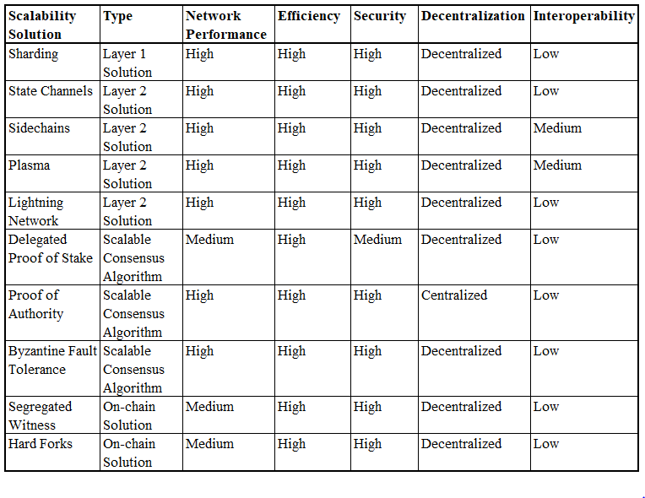

The table below summarizes the variety of scalability solutions based on their advantages and disadvantages.

|  |  |  |  |
| --- | --- | --- | --- |
| **Scalability Solution** | **Description** | **Pros** | **Cons** |
| Sharding | Divides the blockchain network into smaller groups of nodes, each processing a subset of transactions | Increased transaction throughput, reduced latency, and improved scalability | Difficult to implement and requires significant changes to the blockchain architecture; potential security risks |
| State Channels | A private channel between two parties that enables them to conduct multiple transactions off-chain | High transaction throughput with minimal fees; private and secure transactions | Requires a high degree of trust between parties; may not be suitable for complex smart contracts or transactions |
| Sidechains | A separate blockchain connected to the main blockchain that can process transactions independently | Increased transaction throughput and scalability; supports interoperability between different blockchains | Requires significant development effort to implement; may introduce new security risks |
| Plasma | A network of sidechains connected to a main blockchain that can process transactions independently and securely | Increased transaction throughput and scalability; supports interoperability between different blockchains | Limited adoption and still in experimental phase |
| Lightning Network | A second layer protocol that enables fast and cheap transactions off-chain | High transaction throughput with minimal fees; instant transaction confirmation | Requires significant development effort to implement; still in experimental phase |
| Delegated Proof of Stake | A consensus algorithm where a group of trusted nodes are elected to validate transactions | High transaction throughput and scalability; energy-efficient | Potential centralization and security risks |
| Proof of Authority | A consensus algorithm where nodes are validated based on their identity or reputation | High transaction throughput and scalability; energy-efficient | Potential centralization and security risks |
| Byzantine Fault Tolerance | A consensus algorithm where nodes work together to reach a consensus on the state of the blockchain | High transaction throughput and scalability; fault-tolerant | Requires a large number of nodes to be effective; potential security risks |
| Segregated Witness | A protocol upgrade that separates transaction data from signature data to increase block size | Increased transaction throughput and improved scalability | Requires a network-wide upgrade to implement |
| Hard Forks | A permanent change to the blockchain protocol that requires all nodes to upgrade to the new version | Can introduce new scalability solutions and upgrades to the network | Potential for network fragmentation and security risks |

CONCLUSION

In conclusion, scalability is a crucial challenge for blockchain technology to address. With the increasing demand for decentralized applications and use cases, blockchain systems must be able to handle a high volume of transactions with low latency and minimal fees. In this report, we explored various scalability solutions, including sharding, second-layer scalability solutions (such as state channels, sidechains, plasma, and lightning network), and scalable consensus algorithms (such as delegated proof of stake, proof of authority, and Byzantine fault tolerance).

Sharding is a promising solution for blockchain scalability, but it has its own set of challenges, such as data availability and security concerns. Second-layer scalability solutions provide a range of benefits, including faster transaction confirmation and lower fees, but they also have limitations such as trust requirements and compatibility issues. Scalable consensus algorithms offer faster block validation times, reduced energy consumption, and increased throughput, but they may require a higher degree of centralization.

Each solution has its own tradeoffs and must be evaluated based on the specific use case and requirements. Overall, the blockchain community must continue to explore and develop new scalability solutions to meet the increasing demand for decentralized systems. By improving scalability, blockchain technology can become more widely adopted and have a greater impact on various industries.

FUTURE SCOPE

The future of scalability solutions for blockchain technology is promising, as developers continue to research and innovate new solutions to tackle the scalability issues faced by blockchain networks. Here are a few potential directions for future scalability solutions:

**Continued Development of Existing Solutions:** Sharding, state channels, sidechains, plasma, and Lightning Network are all promising scalability solutions that are still being developed and refined. It is likely that developers will continue to improve upon these solutions and implement them in various blockchain networks.

**Hybrid Solutions:** It is possible that in the future, blockchain networks may use a combination of different scalability solutions in order to achieve optimal performance. For example, a network could use sharding to improve transaction throughput, while also implementing state channels for fast and inexpensive micropayments.

**New Consensus Algorithms:** While proof of work and proof of stake are currently the most widely used consensus algorithms in blockchain networks, there are other consensus algorithms being developed that could offer improved scalability. For example, Avalanche is a consensus algorithm that aims to achieve high throughput by quickly finalizing transactions through repeated random sampling of the network.

**Interoperability:** As more blockchain networks are developed, it becomes increasingly important for these networks to be able to communicate and transact with one another. Interoperability solutions such as cross-chain communication and interoperability protocols like Polkadot could help facilitate this.

Overall, the future of scalability solutions for blockchain technology is exciting, with many promising developments on the horizon. As the demand for blockchain technology continues to grow, it is likely that developers will continue to innovate new solutions to overcome scalability challenges and improve the performance of blockchain networks.

REFERENCES

1. <https://www.wipro.com/blogs/hitarshi-buch/improving-performance-and-scalability-of-blockchain-networks/>
2. <https://www.leewayhertz.com/blockchain-scalability-solutions/>
3. <https://101blockchains.com/blockchain-scalability-solutions/>
4. <https://crypto.com/university/what-are-sidechains-scaling-blockchain>
5. <https://whizord.com/unlocking-the-mystery-of-blockchain-technology/>